Chapter 6: Link Prospecting
In this chapter we will be analyzing related SERPs to our keyword and looking for places to drop links. Say there is a forum powered by Vbulletin ranking on the 5th page for a relevant keyword. It would be easy to go and drop a link on that page right? First register for the forum, make a legit profile, go post a few times in other threads, then go drop a nice juicy link on an already indexed page.
Or if you’re feeling real ambitious, train a VA to run this entire process for you.
Because you see, this same methodology can be applied on a massive level by scanning formultiple platform types.
Using a list of the most popular community and publishing platforms, you should be able to create simple html footprints and scan all the urls to identify the potential link drop opportunities.
There are two main approaches that we can use this technique for.
1. Simply analyzing urls related to the target keyword for link dropportunities (see what I did there).
2. Performing deeper analysis on targeted scrapes
For both methods we will be using the page analyzer plugin to analyze the html code of all the pages we dig up.
Method #1 – Find Ranking Related Link Dropportunities
Start by scraping a bunch of keyword suggestions closely related to your target keyword.
Set the results to 1,000 and harvest.
Remove dupe urls and open the page scanner addon.
Once the page scanner is open you will need to create the footprints for it to scan with.
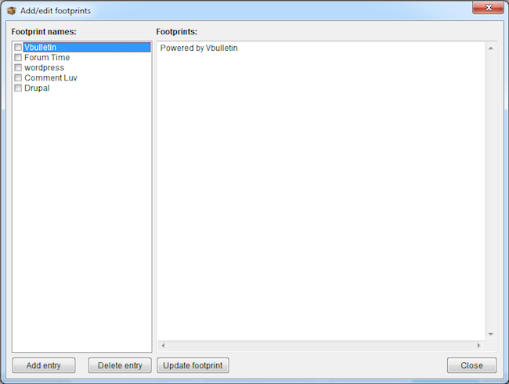
Here are some example footprints:
Platform – WordPress
wp-content
Platform – Drupal
Platform – Vbulletin
Platform – General Forum
All times are GMT
Note that these footprints are different than the traditional footprints we are building when scanning for onpage text. We are taking it one step further and scanning the actual source code of the returned pages for a common html element. If you invest the time, you can build extremely accurate footprints and basically find any platform out there.
After you have inputted the footprints and run the analyzer, export your results. All of the results will be exported and named by the footprint name. So your Vbullletin link dropportunities will all be one file name Vbulletin.
Now continue your hunt and perform further link prospecting analysis on the page level.
Check PR, OBLs PA/DA, etc. When completed you will have a finely tuned list of relevant potential backlink targets to either hand over to a VA or run a posting script on.
Method #2 – General Page Scanning for Targeted Link Dropportunities
With this method I’m going to show you an actual exploit that I discovered the other day to clearly explain this technique.
We are going to be finding blogs with the Comment Luv platform and do-follow links enabled.
All you will need is a few bogey Twitter accounts to tweet the post and get a choice of the post you want to link to.
*Note – This technique requires your site having a blog feed.
To start we are going to be using an onpage footprint to dig up these potential comment luv dofollow drops.
Here is the footprint I created, a common piece of text found right by the comment box, comes default on all Comment Luv installs.
“Confirm you are NOT a spammer” “(dofollow)”
And a bit of SEO irony there!
Now save that badboy to a txt file as “Comment Luv Footprint” or something dear to your heart.
Bust out the keyword scraper and start scraping a shit ton of related suggestions.
Now click the M button and merge that beast in with all your freshly scraped keywords. Click start and get ready to unleash the hogs of war.
When the results are in, remove dupes, and open up the page analyzer addon.
Now create a new footprint called “Comment Luv”
And here is the Gem of an html footprint that my buddy Robert Neu came up with.
Sorry code wrap not working, check back later.
Thanks Robert!
Now run the analyzer and you’ll have some crisp comment luv enabled dofollow blogs to go link drop your face off.
Hopefully you are starting to see the potential of the page scanner and the wheels are turning. Maybe an evil laugh also?
http://www.jacobking.com/free-sb-guide

